MIDTERM EXAMINATION
Spring 2010
MTH101- Calculus And Analytical Geometry

Time: 60 min
Marks: 40

Question No: 1 ( Marks: 1 ) - Please choose one
30⁰ = ________

► 
► 
► 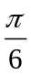

► 

Question No: 2 ( Marks: 1 ) - Please choose one

Let a function  be defined on an interval, and let  and 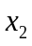 denotes two distinct points in that interval. If 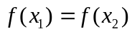 for all points and then which of the following statement is correct?
► is a decreasing function
► is an increasing function
► is a constant function

Question No: 3 ( Marks: 1 ) - Please choose one
Tan(x) is continuous every where except at points

► 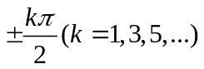
► 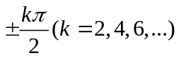
► 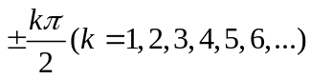

Question No: 4 ( Marks: 1 ) - Please choose one
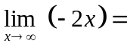
► -2
► 0
► 2
► Does not exist

Question No: 5 ( Marks: 1 ) - Please choose one
Suppose that and are differentiable functions of then
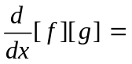

► 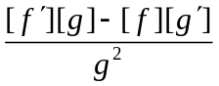
► 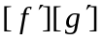
► 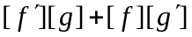
► 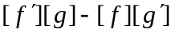

Question No: 6 ( Marks: 1 ) - Please choose one
The solution set of the inequality 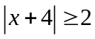 is

► 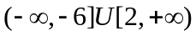
► None of these
► 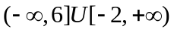
► 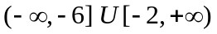

Question No: 7 ( Marks: 1 ) - Please choose one
A line is called a tangent line to the circle if it meets the circle at precisely ……………..

► One point
► Two points
► Infinite points
Question No: 8 ( Marks: 1 ) - Please choose one
Let a function be defined on an interval, and let and denote points in that interval. If 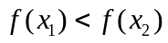 whenever 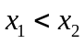 then which of the following statement is correct?
► is an increasing function.
► is a decreasing function.
► is a constant function.

Question No: 9 ( Marks: 1 ) - Please choose one
If 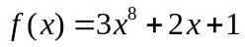 then 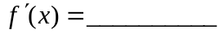
► 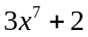
► 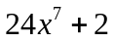
► 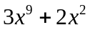
► 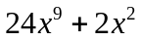
Question No: 10 ( Marks: 1 ) - Please choose one
is a .............number

► Integer
► Rational
► Irrational
► Natural

Question No: 11 ( Marks: 1 ) - Please choose one
The set 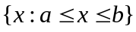 can be written in the form of interval

► (a,b)
► (a,b]
► [a,b]

Question No: 12 ( Marks: 1 ) - Please choose one
Suppose that and are differentiable functions of then
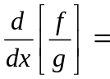
► 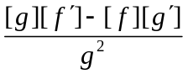
► 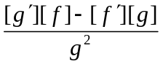
► 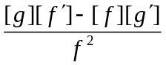
► 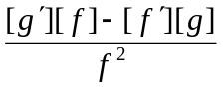

Question No: 13 ( Marks: 1 ) - Please choose one
The graph 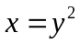 is symmetric about ---------axis

► X-axis
► Y-axis
► Origin

Question No: 14 ( Marks: 1 ) - Please choose one
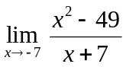

► -14
► 0
►
► Limit does not exis

Question No: 15 ( Marks: 1 ) - Please choose one
Chain rule is a rule for differentiating ___________ of functions.
► Product
► Sum
► Difference
► Composition

Question No: 16 ( Marks: 1 ) - Please choose one
The 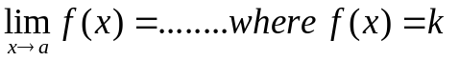(k is a constant)

► k+2
► k+1
► k

Question No: 17 ( Marks: 1 ) - Please choose one
For any number 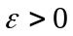if we can find an open interval 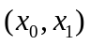on the x-axis containing the point "a" such that 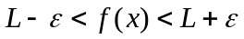 for each x in except the possible x = a then we say 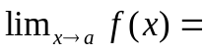---------

►
► 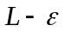
► 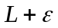
► 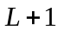

Question No: 18 ( Marks: 1 ) - Please choose one
If 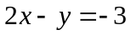 then 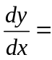
► 2
► -2
► 0
► -3

Question No: 19 ( Marks: 1 ) - Please choose one
The graph of the equation 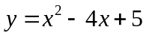 will represent

► Parabola
► Straight line
► Two straight lines

► Ellipse

Question No: 20 ( Marks: 1 ) - Please choose one
The equation of line of the form 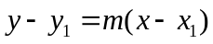 is known as

► Point-slope form
► Two points form
► Intercepts form
► Slope intercept form

Question No: 21 ( Marks: 2 )
If 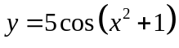 Find dy/dx by using "The chain rule".

Question No: 22 ( Marks: 2 )
Prove that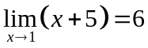, using the definition of limit.

Question No: 23 ( Marks: 3 )
Find an equation of the tangent line to the curve

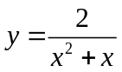at the point where 

Question No: 24 ( Marks: 3 )
Compute 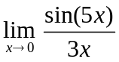

Question No: 25 ( Marks: 5 )
Find all critical points of 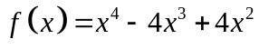

Question No: 26 ( Marks: 5 )
Find  if 